Supplementary Table 1. Baseline characteristics of patients with SIMI stratified by PLT/LDH ratio tertiles.
Characteristics | Low  (n = 1,024) | Middle  (n = 1,023) | High  (n = 1,024) | p value
Age, mean (SD) | 60.845 (18.575) | 66.272 (18.732) | 60.871 (20.060) | <0.001
Gender |  |  |  | <0.001
Female, n (%) | 385 (37.598) | 338 (33.040) | 297 (29.004)
Male, n (%) | 639 (62.402) | 685 (66.960) | 727 (70.996)
Comorbidity
Hypertension, n (%) | 200 (19.531) | 166 (24.412) | 443 (43.262) | <0.001
DM, n (%) | 141 (13.770) | 217 (21.212) | 249 (24.316) | <0.001
CAD, n (%) | 102 (9.961) | 150 (14.663) | 166 (16.211) | <0.001
Laboratory examination
WBC count (10⁹/L), median (IQR) | 9.460  (8.362-9.900) | 9.530  (8.585-9.940) | 9.315  (8.050-9.830) | <0.001
RBC count (10¹²/L), median (IQR) | 3.570  (3.120-4.140) | 3.590  (3.180-4.090) | 3.715  (3.200-4.220) | 0.025
PLT (10⁹/L), median (IQR) | 87.000  (60.000-96.000) | 96.000  (90.000-112.000) | 289.000 (209.000-385.500) | <0.001
PT (s), median (IQR) | 21.600  (17.600-32.600) | 17.000  (15.200-21.025) | 15.800  (14.400-18.000) | <0.001
INR, median (IQR) | 1.870  (1.440-3.060) | 1.390  (1.200-1.810) | 1.260  (1.120-1.485) | <0.001
CRP (mg/dL), median (IQR) | 8.512  (5.075-9.670) | 7.360  (2.851-9.349) | 6.192  (1.140-9.007) | <0.001
IL-6 (ng/L), median (IQR) | 95.920  (59.240-1000.000) | 65.540  (8.398-95.562) | 20.700  (7.075-87.715) | <0.001
ALT (U/L), median (IQR) | 57.500  (9.600-93.950) | 15.700  (9.200-66.400) | 9.900  (8.900-55.800) | <0.001
AST (U/L), median (IQR) | 82.500  (51.075-97.200) | 42.300  (18.300-75.000) | 28.850  (9.800-62.625) | <0.001
BUN (mg/dL), median (IQR) | 9.590  (8.612-9.970) | 9.560  (8.335-21.285) | 9.600  (8.210-19.885) | 0.146
SCR (μmol/L), median (IQR) | 95.100  (82.750-159.475) | 97.100  (83.650-365.525) | 98.600  (74.875-442.125) | <0.001
Lac (mmol/L), median (IQR) | 5.235  (2.900–8.275) | 2.700  (1.890–4.500) | 2.400  (1.700–3.425) | <0.001
LDH (U/L), median (IQR) | 756.400  (568.450-926.500) | 346.800  (271.800-451.150) | 261.400  (189.000-337.150) | <0.001
HGB (g/L), median (IQR) | 97.699 (18.077) | 101.689 (20.404) | 102.360 (22.105) | <0.001
Fibrinogen (g/L), mean (SD) | 4.788 (1.915) | 4.911 (1.798) | 5.411 (1.639) | <0.001
D-dimer (mg/L), median (IQR) | 9.215  (5.900-20.000) | 5.980  (2.900-8.950) | 4.155  (2.070-7.715) | <0.001
cTnT (ng/mL), median (IQR) | 0.151  (0.061-0.401) | 0.087  (0.036-0.189) | 0.059  (0.027-0.131) | <0.001
Myoglobin (ng/mL), median (IQR) | 97.650  (61.375-857.500) | 92.850  (57.150-265.700) | 79.200  (21.000-98.800) | <0.001
CK-MB (μg/L), median (IQR) | 5.360  (2.185-8.668) | 3.235  (1.548-5.785) | 2.340  (1.220-4.540) | <0.001
Critical assessment on admission
SOFA score, median (IQR) | 6.000  (5.000-8.000) | 5.000  (3.000-6.000) | 4.000  (3.000-4.000) | <0.001
CHARLSON score, median (IQR) | 2.000  (0.000-3.000) | 2.000  (0.000-3.000) | 2.000  (0.000-3.000) | 0.006
Data are presented as mean ± standard deviation (SD) or median (interquartile range, IQR) for continuous variables, and as number (%) for categorical variables. Group comparisons were performed using Student's t-test or Mann-Whitney U test for continuous variables, and the chi-square test or Fisher's exact test for categorical variables, as appropriate. SIMI, sepsis-induced myocardial injury; cTnT, cardiac troponin T; WBC, white blood cell count; RBC, red blood cell count; PLT, platelet count; PT, prothrombin time; INR, international normalized ratio; CRP, C-reactive protein; IL-6, interleukin-6; ALT, alanine aminotransferase; AST, aspartate aminotransferase; BUN, blood urea nitrogen; Scr, serum creatinine; Lac, lactate; LDH, lactate dehydrogenase; HGB, hemoglobin; CK-MB, creatine kinase-MB; SOFA, Sequential Organ Failure Assessment.

Supplementary Table 2. Area under the curve (AUC) of PLT/LDH ratio, PLT, and LDH for predicting in-hospital mortality
Variables | AUC (95% CI) | p value
PLT/LDH | 0.696 (0.672-0.72)
PLT | 0.648 (0.623-0.672) | <0.001
LDH | 0.668 (0.643-0.693) | 0.002
Comparisons of AUCs were performed using the DeLong test. P values indicate statistical significance of the difference in AUC between the PLT/LDH ratio and each individual marker. PLT: platelet count; LDH: lactate dehydrogenase.

Supplementary Table 3. Model performance metrics comparing base model with and without PLT/LDH ratio
Model | C-index (95% CI) | Δ C-index | IDI (95% CI) | NRI | Brier Score (28-day) | Calibration Slope
Base (Age + Sex + SOFA) | 0.726 (0.700-0.752) | — | — | — | 0.1370 | 1.000
Base + PLT/LDH ratio | 0.744 (0.718-0.770) | +0.018 | 0.0093 (0.0046-0.0152) | 0.0267 | 0.1367 | 0.996
p value | — | <0.001 | <0.001 | — | — | —
Abbreviations: IDI, integrated discrimination improvement; NRI, net reclassification improvement; CI, confidence interval.
Notes: C-index values were calculated using Somers' D statistic with 1,000 bootstrap resamples for optimism correction. Brier scores and calibration slopes were evaluated at 28 days. Calibration slopes close to 1.0 indicate good calibration for both models.IDI and NRI were calculated at the 28-day time point using the following risk categories: low (<0.2), moderate (0.2-0.5), and high (>0.5).

Supplementary Table 4. Comparison of the PLT/LDH ratio with PLT and LDH as separate nonlinear terms
Model | Log-likelihood | C-index | LRT χ² | df | p value
PLT + LDH (RCS, 3 knots each) + covariates | −4,221.8 | 0.621 | — | — | —
PLT + LDH (RCS) + PLT/LDH ratio + covariates | −4,221.6 | 0.621 | 0.31 | 1 | 0.578
Abbreviations: RCS, restricted cubic splines; LRT, likelihood ratio test; df, degrees of freedom.
Covariates: age, sex, SOFA score, Charlson comorbidity index.
Note: C-index values reflect the discriminative performance of the linear predictor from each model. The LRT compares the model with PLT/LDH ratio against the model without it.

Supplementary Table 5. cTnT-stratified analysis of the association between PLT/LDH ratio and in-hospital mortality
Stratum | n | HR (95% CI) | p value
Low (≤5× URL) | 1,018 | 0.923 (0.668-1.277) | 0.629
Moderate (5-20× URL) | 1,238 | 0.343 (0.223-0.527) | <0.001
High (>20× URL) | 815 | 0.338 (0.198-0.574) | <0.001
Interaction P value: 0.008.
Abbreviations: URL, upper reference limit (0.01 ng/mL); HR, hazard ratio; CI, confidence interval.
Note: Stratification was based on the fold-increase of cardiac troponin T (cTnT) above the upper reference limit. Multifactorial Cox models were adjusted for age, sex, SOFA score, and Charlson comorbidity index.

Supplementary Table 6. Creatinine-stratified analysis of the association between PLT/LDH ratio and in-hospital mortality
Stratum | n | HR (95% CI) | p value
T1 (≤80.7 μmol/L) | 753 | 0.673 (0.454-0.999) | 0.049
T2 (80.7-96.6 μmol/L) | 768 | 0.713 (0.468-1.084) | 0.113
T3 (>96.6 μmol/L) | 1,517 | 0.206 (0.124-0.343) | <0.001
Interaction P value: <0.001.
Abbreviations: HR, hazard ratio; CI, confidence interval.
Note: Of the 3071 patients in the final analysis cohort, 33 had missing serum creatinine data and were excluded from this stratified analysis. The remaining 3038 patients were stratified into tertiles based on serum creatinine. Multifactorial Cox models were adjusted for age, sex, SOFA score, and Charlson comorbidity index

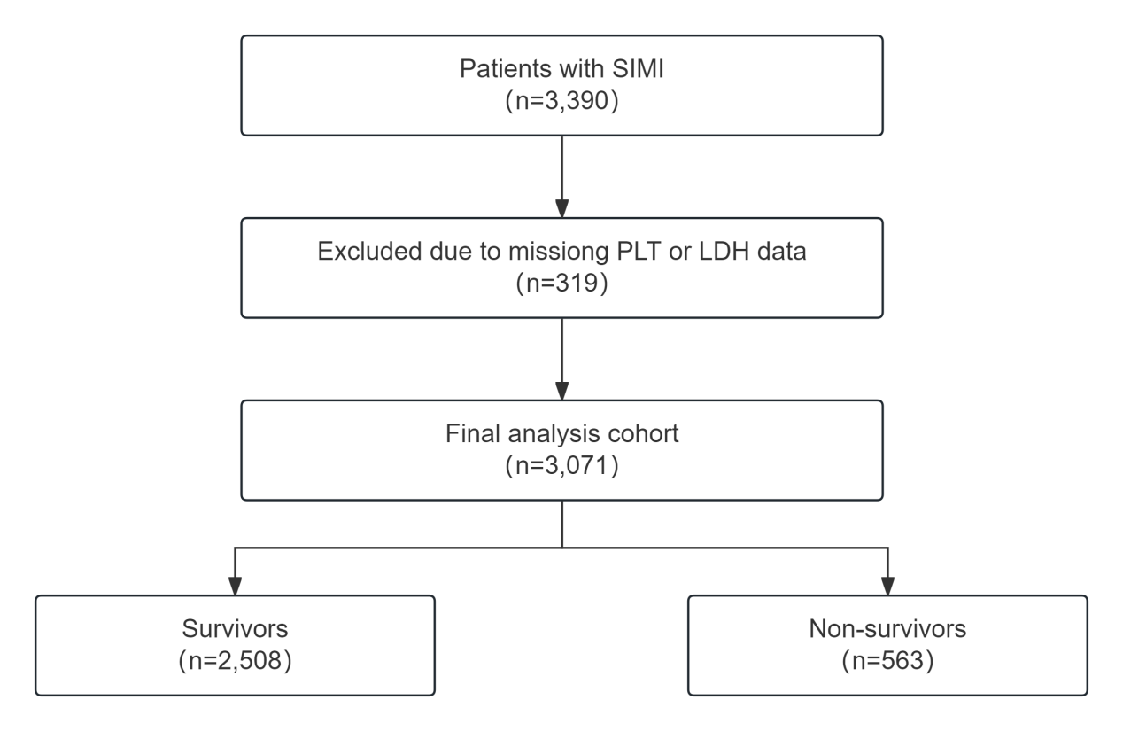
Supplementary Fig. 1. Patient flow diagram. A total of 3,390 patients with sepsis-induced myocardial injury (SIMI) were initially screened. After excluding 319 patients with missing platelet count (PLT) or lactate dehydrogenase (LDH) data, 3,071 patients were included in the final analysis cohort, of whom 2,508 survived to hospital discharge and 563 died during hospitalization. Abbreviation: SIMI, sepsis-induced myocardial injury.

